ПРОДЕЛКА РАБОТЫ
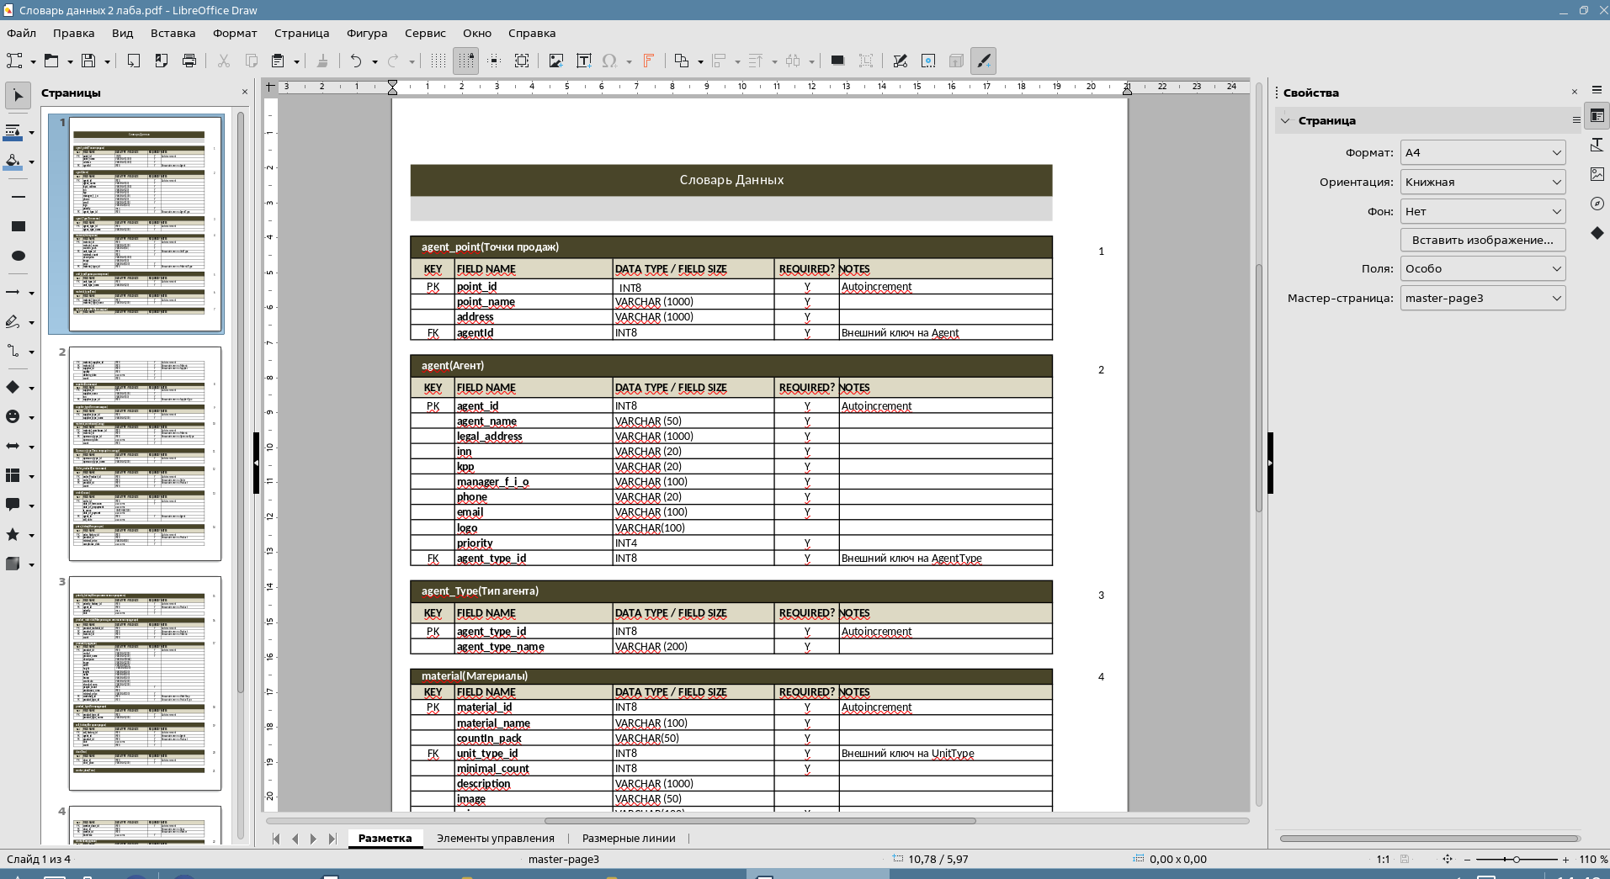
ПРОДЕЛКА РАБОТЫ
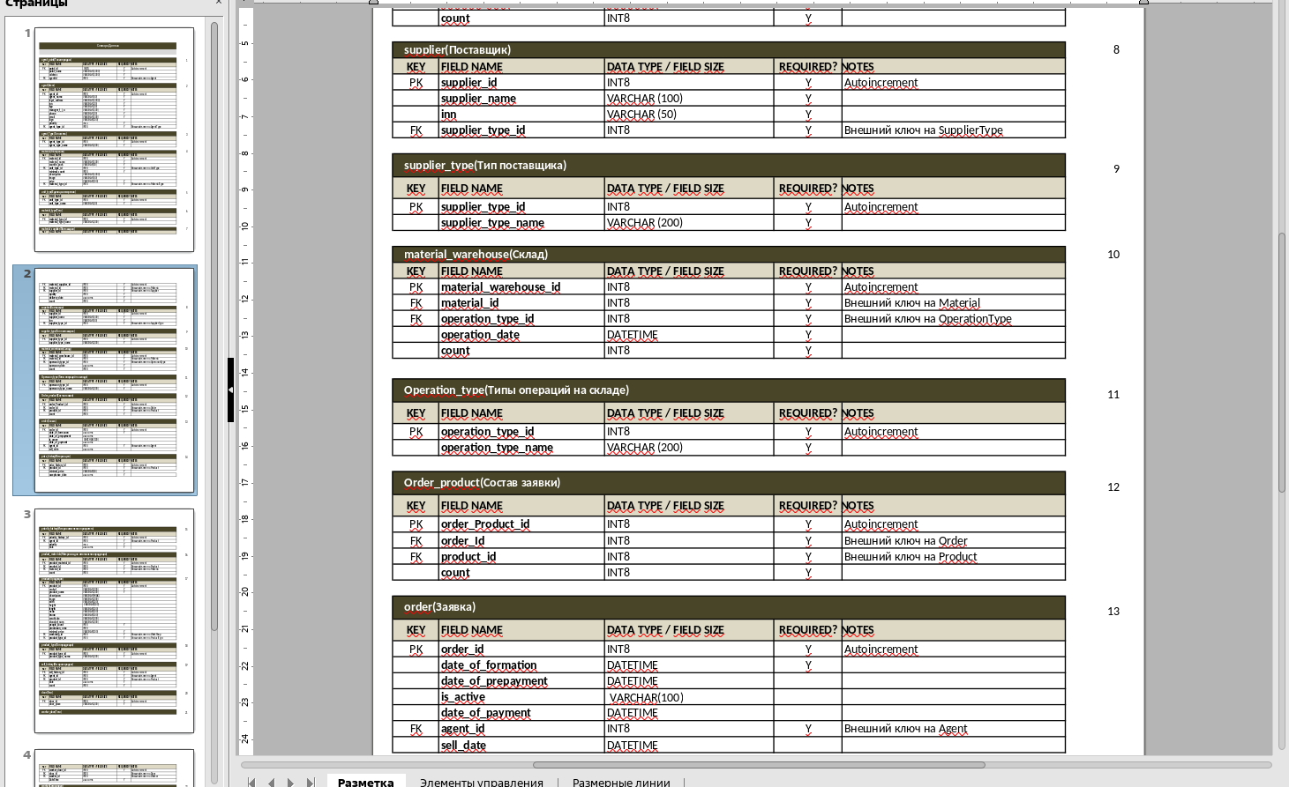
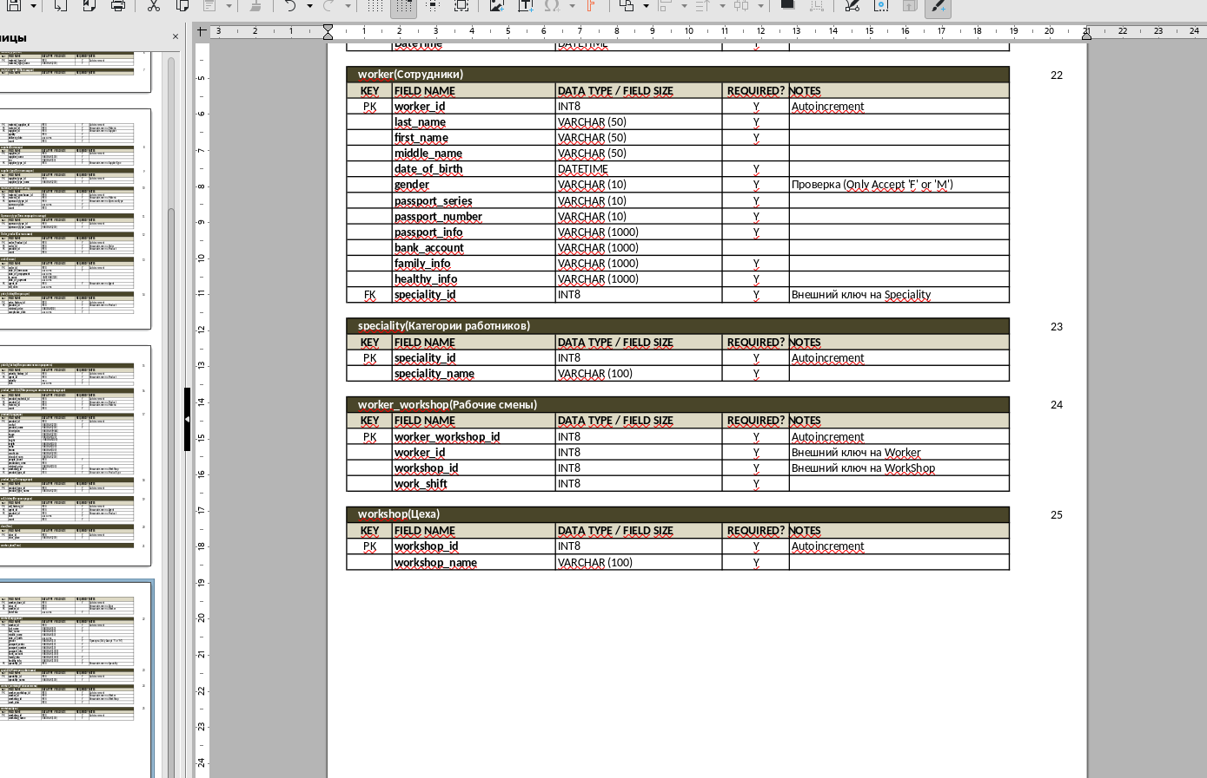
ПРОДЕЛКА РАБОТЫ
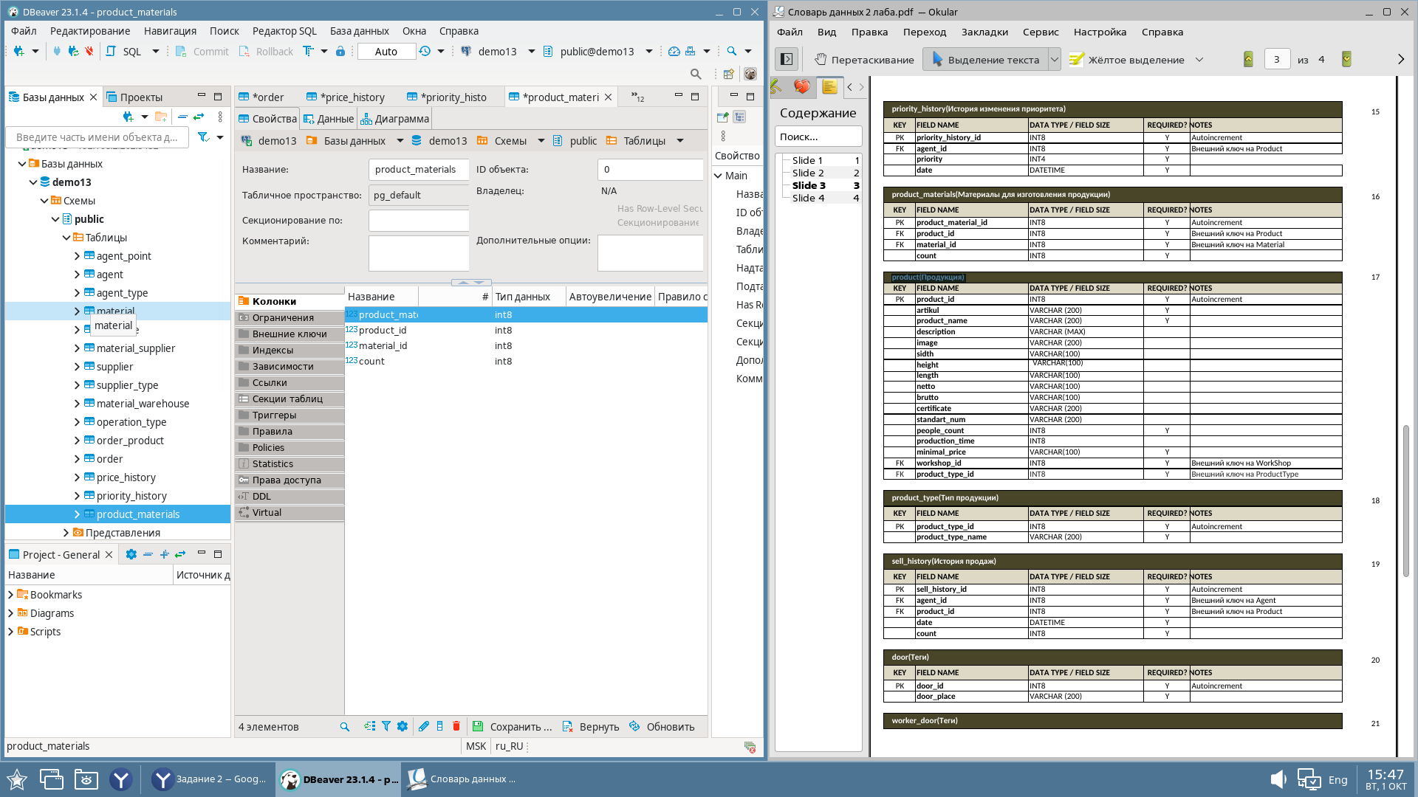
ПРОДЕЛКА РАБОТЫ
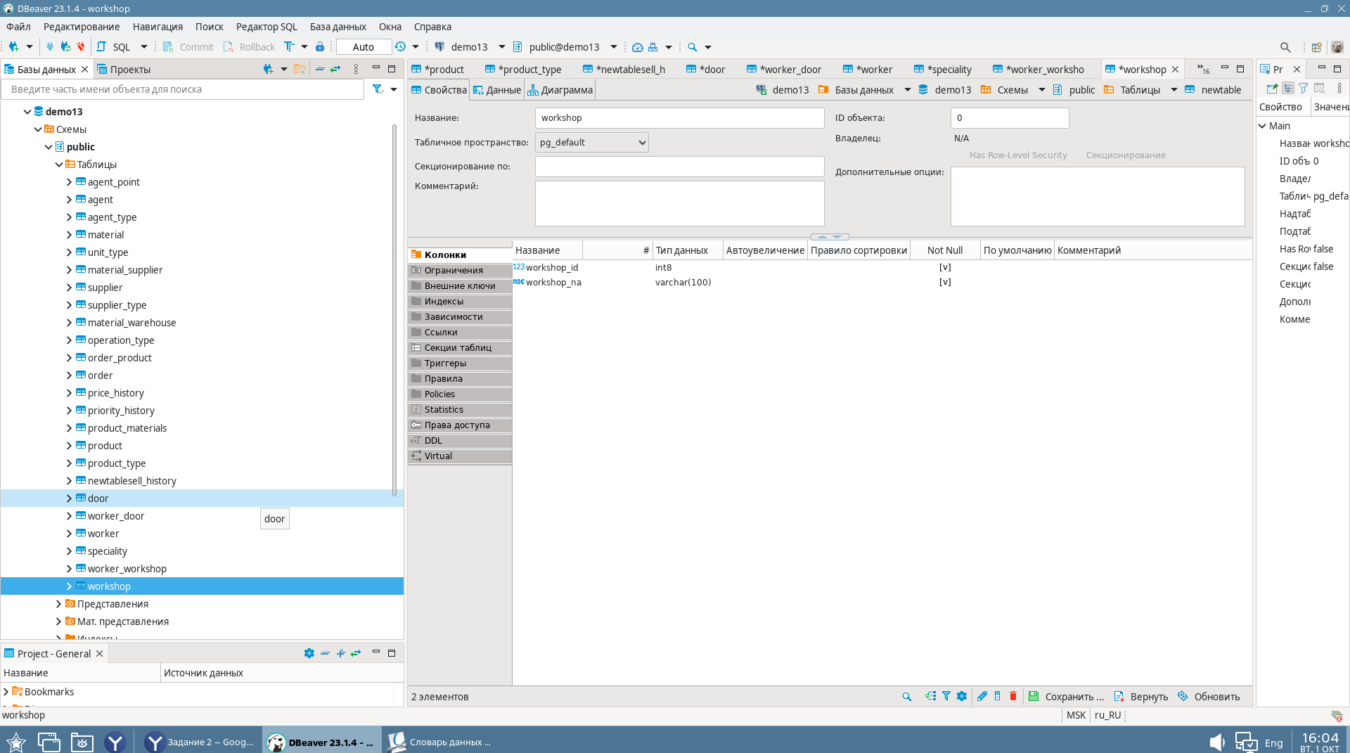
2 ЗАДАНИЕ ГОТОВЫ

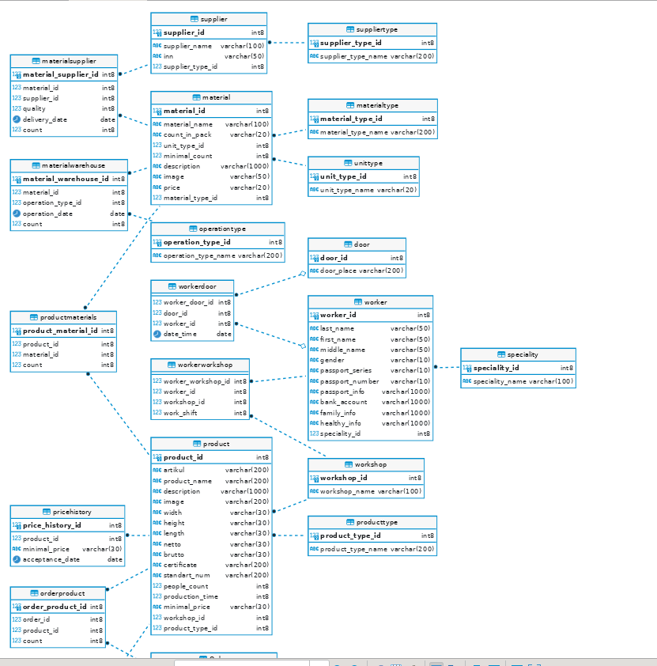
СКРИПТ;
-- DROP SCHEMA public;

CREATE SCHEMA public AUTHORIZATION postgres;

COMMENT ON SCHEMA public IS 'standard public schema';
-- public.agent definition

-- Drop table

-- DROP TABLE public.agent;

CREATE TABLE public.agent (
agent_id int8 NOT NULL,
agent_name varchar(50) NOT NULL,
legal_address varchar(1000) NOT NULL,
inn varchar(20) NOT NULL,
kpp varchar(20) NOT NULL,
manager_fio varchar(100) NOT NULL,
phone varchar(20) NOT NULL,
email varchar(100) NOT NULL,
logo varchar(100) NULL,
priority int4 NOT NULL,
agent_type_id int8 NOT NULL,
CONSTRAINT agent_pk PRIMARY KEY (agent_id)
);

-- Permissions

ALTER TABLE public.agent OWNER TO user15;
GRANT ALL ON TABLE public.agent TO user15;

-- public.agenttype definition

-- Drop table

-- DROP TABLE public.agenttype;

CREATE TABLE public.agenttype (
agenttypeid int8 NOT NULL,
agenttypename varchar(200) NOT NULL,
CONSTRAINT agenttype_pk PRIMARY KEY (agenttypeid)
);

-- Permissions

ALTER TABLE public.agenttype OWNER TO user15;
GRANT ALL ON TABLE public.agenttype TO user15;

-- public.unittype definition

-- Drop table

-- DROP TABLE public.unittype;

CREATE TABLE public.unittype (
unit_type_id int8 NOT NULL,
unit_type_name varchar(20) NOT NULL,
CONSTRAINT unittype_pk PRIMARY KEY (unit_type_id)
);

-- Permissions

ALTER TABLE public.unittype OWNER TO user15;
GRANT ALL ON TABLE public.unittype TO user15;

-- public.materialtype definition

-- Drop table

-- DROP TABLE public.materialtype;

CREATE TABLE public.materialtype (
material_type_id int8 NOT NULL,
material_type_name varchar(200) NOT NULL,
CONSTRAINT materialtype_pk PRIMARY KEY (material_type_id)
);

-- Permissions

ALTER TABLE public.materialtype OWNER TO user15;
GRANT ALL ON TABLE public.materialtype TO user15;

-- public.suppliertype definition

-- Drop table

-- DROP TABLE public.suppliertype;

CREATE TABLE public.suppliertype (
supplier_type_id int8 NOT NULL,
supplier_type_name varchar(200) NOT NULL,
CONSTRAINT suppliertype_pk PRIMARY KEY (supplier_type_id)
);

-- Permissions

ALTER TABLE public.suppliertype OWNER TO user15;
GRANT ALL ON TABLE public.suppliertype TO user15;

-- public.operationtype definition

-- Drop table

-- DROP TABLE public.operationtype;

CREATE TABLE public.operationtype (
operation_type_id int8 NOT NULL,
operation_type_name varchar(200) NOT NULL,
CONSTRAINT operationtype_pk PRIMARY KEY (operation_type_id)
);

-- Permissions

ALTER TABLE public.operationtype OWNER TO user15;
GRANT ALL ON TABLE public.operationtype TO user15;

-- public.priorityhistory definition

-- Drop table

-- DROP TABLE public.priorityhistory;

CREATE TABLE public.priorityhistory (
priority_history_id int8 NOT NULL,
agent int8 NOT NULL,
priority int4 NOT NULL,
"date" date NOT NULL,
CONSTRAINT priorityhistory_pk PRIMARY KEY (priority_history_id)
);

-- Permissions

ALTER TABLE public.priorityhistory OWNER TO user15;
GRANT ALL ON TABLE public.priorityhistory TO user15;

-- public.producttype definition

-- Drop table

-- DROP TABLE public.producttype;

CREATE TABLE public.producttype (
product_type_id int8 NOT NULL,
product_type_name varchar(200) NOT NULL,
CONSTRAINT producttype_pk PRIMARY KEY (product_type_id)
);

-- Permissions

ALTER TABLE public.producttype OWNER TO user15;
GRANT ALL ON TABLE public.producttype TO user15;

-- public.door definition

-- Drop table

-- DROP TABLE public.door;

CREATE TABLE public.door (
door_id int8 NOT NULL,
door_place varchar(200) NOT NULL,
CONSTRAINT door_pk PRIMARY KEY (door_id)
);

-- Permissions

ALTER TABLE public.door OWNER TO user15;
GRANT ALL ON TABLE public.door TO user15;

-- public.speciality definition

-- Drop table

-- DROP TABLE public.speciality;

CREATE TABLE public.speciality (
speciality_id int8 NOT NULL,
speciality_name varchar(100) NOT NULL,
CONSTRAINT speciality_pk PRIMARY KEY (speciality_id)
);

-- Permissions

ALTER TABLE public.speciality OWNER TO user15;
GRANT ALL ON TABLE public.speciality TO user15;

-- public.workshop definition

-- Drop table

-- DROP TABLE public.workshop;

CREATE TABLE public.workshop (
workshop_id int8 NOT NULL,
workshop_name varchar(100) NOT NULL,
CONSTRAINT workshop_pk PRIMARY KEY (workshop_id)
);

-- Permissions

ALTER TABLE public.workshop OWNER TO user15;
GRANT ALL ON TABLE public.workshop TO user15;

-- public.agentpoint8 definition

-- Drop table

-- DROP TABLE public.agentpoint8;

CREATE TABLE public.agentpoint8 (
point8_id int8 NOT NULL,
point8_name varchar(1000) NOT NULL,
address varchar(1000) NOT NULL,
agent_id int8 NOT NULL,
CONSTRAINT agentpoint8_pk PRIMARY KEY (point8_id),
CONSTRAINT agentpoint8_fk FOREIGN KEY (agent_id) REFERENCES public.agent(agent_id)
);

-- Permissions

ALTER TABLE public.agentpoint8 OWNER TO user15;
GRANT ALL ON TABLE public.agentpoint8 TO user15;

-- public.material definition

-- Drop table

-- DROP TABLE public.material;

CREATE TABLE public.material (
material_id int8 NOT NULL,
material_name varchar(100) NOT NULL,
count_in_pack varchar(20) NOT NULL,
unit_type_id int8 NOT NULL,
minimal_count int8 NOT NULL,
description varchar(1000) NULL,
image varchar(50) NULL,
price varchar(20) NOT NULL,
material_type_id int8 NOT NULL,
CONSTRAINT material_pk PRIMARY KEY (material_id),
CONSTRAINT material_fk FOREIGN KEY (material_type_id) REFERENCES public.materialtype(material_type_id),
CONSTRAINT material_fk_1 FOREIGN KEY (unit_type_id) REFERENCES public.unittype(unit_type_id)
);

-- Permissions

ALTER TABLE public.material OWNER TO user15;
GRANT ALL ON TABLE public.material TO user15;

-- public.supplier definition

-- Drop table

-- DROP TABLE public.supplier;

CREATE TABLE public.supplier (
supplier_id int8 NOT NULL,
supplier_name varchar(100) NOT NULL,
inn varchar(50) NOT NULL,
supplier_type_id int8 NOT NULL,
CONSTRAINT supplier_pk PRIMARY KEY (supplier_id),
CONSTRAINT supplier_fk FOREIGN KEY (supplier_type_id) REFERENCES public.suppliertype(supplier_type_id)
);

-- Permissions

ALTER TABLE public.supplier OWNER TO user15;
GRANT ALL ON TABLE public.supplier TO user15;

-- public.materialwarehouse definition

-- Drop table

-- DROP TABLE public.materialwarehouse;

CREATE TABLE public.materialwarehouse (
material_warehouse_id int8 NOT NULL,
material_id int8 NOT NULL,
operation_type_id int8 NOT NULL,
operation_date date NOT NULL,
count int8 NOT NULL,
CONSTRAINT materialwarehouse_pk PRIMARY KEY (material_warehouse_id),
CONSTRAINT materialwarehouse_fk FOREIGN KEY (material_id) REFERENCES public.material(material_id),
CONSTRAINT materialwarehouse_fk_1 FOREIGN KEY (operation_type_id) REFERENCES public.operationtype(operation_type_id)
);

-- Permissions

ALTER TABLE public.materialwarehouse OWNER TO user15;
GRANT ALL ON TABLE public.materialwarehouse TO user15;

-- public."Order" definition

-- Drop table

-- DROP TABLE public."Order";

CREATE TABLE public."Order" (
order_id int8 NOT NULL,
date_of_formation date NOT NULL,
date_of_prepayment date NULL,
is_active varchar(20) NULL,
date_of_payment date NULL,
agent_id int8 NOT NULL,
sell_date date NULL,
CONSTRAINT order_pk PRIMARY KEY (order_id),
CONSTRAINT order_fk FOREIGN KEY (agent_id) REFERENCES public.agent(agent_id)
);

-- Permissions

ALTER TABLE public."Order" OWNER TO user15;
GRANT ALL ON TABLE public."Order" TO user15;

-- public.product definition

-- Drop table

-- DROP TABLE public.product;

CREATE TABLE public.product (
product_id int8 NOT NULL,
artikul varchar(200) NOT NULL,
product_name varchar(200) NOT NULL,
description varchar(1000) NULL,
image varchar(200) NULL,
width varchar(30) NULL,
height varchar(30) NULL,
length varchar(30) NULL,
netto varchar(30) NULL,
brutto varchar(30) NULL,
certificate varchar(200) NULL,
standart_num varchar(200) NULL,
people_count int8 NOT NULL,
production_time int8 NULL,
minimal_price varchar(30) NOT NULL,
workshop_id int8 NOT NULL,
product_type_id int8 NOT NULL,
CONSTRAINT product_pk PRIMARY KEY (product_id),
CONSTRAINT product_fk FOREIGN KEY (workshop_id) REFERENCES public.workshop(workshop_id),
CONSTRAINT product_fk_1 FOREIGN KEY (product_type_id) REFERENCES public.producttype(product_type_id)
);

-- Permissions

ALTER TABLE public.product OWNER TO user15;
GRANT ALL ON TABLE public.product TO user15;

-- public.sellhistory definition

-- Drop table

-- DROP TABLE public.sellhistory;

CREATE TABLE public.sellhistory (
sell_history_id varchar NOT NULL,
agent_id int8 NOT NULL,
product_id int8 NOT NULL,
"date" date NOT NULL,
count int8 NOT NULL,
CONSTRAINT sellhistory_pk PRIMARY KEY (sell_history_id),
CONSTRAINT sellhistory_fk FOREIGN KEY (agent_id) REFERENCES public.agent(agent_id),
CONSTRAINT sellhistory_fk_1 FOREIGN KEY (product_id) REFERENCES public.product(product_id)
);

-- Permissions

ALTER TABLE public.sellhistory OWNER TO user15;
GRANT ALL ON TABLE public.sellhistory TO user15;

-- public.worker definition

-- Drop table

-- DROP TABLE public.worker;

CREATE TABLE public.worker (
worker_id int8 NOT NULL,
last_name varchar(50) NOT NULL,
first_name varchar(50) NOT NULL,
middle_name varchar(50) NULL,
gender varchar(10) NOT NULL,
passport_series varchar(10) NOT NULL,
passport_number varchar(10) NOT NULL,
passport_info varchar(1000) NOT NULL,
bank_account varchar(1000) NULL,
family_info varchar(1000) NOT NULL,
healthy_info varchar(1000) NOT NULL,
speciality_id int8 NOT NULL,
CONSTRAINT worker_pk PRIMARY KEY (worker_id),
CONSTRAINT worker_fk FOREIGN KEY (speciality_id) REFERENCES public.speciality(speciality_id)
);

-- Permissions

ALTER TABLE public.worker OWNER TO user15;
GRANT ALL ON TABLE public.worker TO user15;

-- public.workerworkshop definition

-- Drop table

-- DROP TABLE public.workerworkshop;

CREATE TABLE public.workerworkshop (
worker_workshop_id int8 NOT NULL,
worker_id int8 NOT NULL,
workshop_id int8 NOT NULL,
work_shift int8 NOT NULL,
CONSTRAINT workerworkshop_fk FOREIGN KEY (worker_id) REFERENCES public.worker(worker_id),
CONSTRAINT workerworkshop_fk_1 FOREIGN KEY (workshop_id) REFERENCES public.workshop(workshop_id)
);

-- Permissions

ALTER TABLE public.workerworkshop OWNER TO user15;
GRANT ALL ON TABLE public.workerworkshop TO user15;

-- public.materialsupplier definition

-- Drop table

-- DROP TABLE public.materialsupplier;

CREATE TABLE public.materialsupplier (
material_supplier_id int8 NOT NULL,
material_id int8 NOT NULL,
supplier_id int8 NOT NULL,
quality int8 NOT NULL,
delivery_date date NOT NULL,
count int8 NOT NULL,
CONSTRAINT materialsupplier_pk PRIMARY KEY (material_supplier_id),
CONSTRAINT materialsupplier_fk FOREIGN KEY (material_id) REFERENCES public.material(material_id),
CONSTRAINT materialsupplier_fk_1 FOREIGN KEY (supplier_id) REFERENCES public.supplier(supplier_id)
);

-- Permissions

ALTER TABLE public.materialsupplier OWNER TO user15;
GRANT ALL ON TABLE public.materialsupplier TO user15;

-- public.orderproduct definition

-- Drop table

-- DROP TABLE public.orderproduct;

CREATE TABLE public.orderproduct (
order_product_id int8 NOT NULL,
order_id int8 NOT NULL,
product_id int8 NOT NULL,
count int8 NOT NULL,
CONSTRAINT orderproduct_pk PRIMARY KEY (order_product_id),
CONSTRAINT orderproduct_fk FOREIGN KEY (order_id) REFERENCES public."Order"(order_id),
CONSTRAINT orderproduct_fk_1 FOREIGN KEY (product_id) REFERENCES public.product(product_id)
);

-- Permissions

ALTER TABLE public.orderproduct OWNER TO user15;
GRANT ALL ON TABLE public.orderproduct TO user15;

-- public.pricehistory definition

-- Drop table

-- DROP TABLE public.pricehistory;

CREATE TABLE public.pricehistory (
price_history_id int8 NOT NULL,
product_id int8 NOT NULL,
minimal_price varchar(30) NOT NULL,
acceptance_date date NOT NULL,
CONSTRAINT pricehistory_pk PRIMARY KEY (price_history_id),
CONSTRAINT pricehistory_fk FOREIGN KEY (product_id) REFERENCES public.product(product_id)
);

-- Permissions

ALTER TABLE public.pricehistory OWNER TO user15;
GRANT ALL ON TABLE public.pricehistory TO user15;

-- public.productmaterials definition

-- Drop table

-- DROP TABLE public.productmaterials;

CREATE TABLE public.productmaterials (
product_material_id int8 NOT NULL,
product_id int8 NOT NULL,
material_id int8 NOT NULL,
count int8 NOT NULL,
CONSTRAINT productmaterials_pk PRIMARY KEY (product_material_id),
CONSTRAINT productmaterials_fk FOREIGN KEY (material_id) REFERENCES public.material(material_id),
CONSTRAINT productmaterials_fk_1 FOREIGN KEY (product_id) REFERENCES public.product(product_id)
);

-- Permissions

ALTER TABLE public.productmaterials OWNER TO user15;
GRANT ALL ON TABLE public.productmaterials TO user15;

-- public.workerdoor definition

-- Drop table

-- DROP TABLE public.workerdoor;

CREATE TABLE public.workerdoor (
worker_door_id int8 NOT NULL,
door_id int8 NULL,
worker_id int8 NULL,
date_time date NOT NULL,
CONSTRAINT workerdoor_fk FOREIGN KEY (door_id) REFERENCES public.door(door_id),
CONSTRAINT workerdoor_fk_1 FOREIGN KEY (worker_id) REFERENCES public.worker(worker_id)
);

-- Permissions

ALTER TABLE public.workerdoor OWNER TO user15;
GRANT ALL ON TABLE public.workerdoor TO user15;

-- Permissions

GRANT ALL ON SCHEMA public TO postgres;
GRANT ALL ON SCHEMA public TO public;

